***Case Study 6.2: Biking day with high carb lunch***  Bernie V.1 04 Oct 2023 . Last part needs to be shortened and reduced to aspects that I am sure about

I set for most of the day a **70% profile**, and had only a minimal breakfast in order to keep iob low when starting to bike.

Additionally I activated the exercise mode, using a **TT=125 mg/dl** which I kept running over lunch time, but shorter than the 70% profile..

In just seconds I was able to „frame“ the upcoming exceptional situation for my loop to manage me fully automatically through the day.

Of course, in my initial tuning I had to first „learn“ from my looping data, whereabout %profile and set TT should lie for that kind of exercise that I was up to. But, no need to make a science out of it. Unless you are competing in profi sports, it should be good enough to go by gut feeling, and by experience („what setting should I slightly alter the next time?“).

Using the top button row on the AAPS main screen, I just input the 70% and 125, which goes super fast and easy. It will immediately turn

* from all three fields grey,
* to lit exercise button in the middle, 70% .. on the profile field-turned-yellow, and 125 .. in the TT field-turned-yellow.

So, very easy to see on one glance, I am in the exercise mode, and which are the key settings (see picture with „95“ glucose below). And in case I want to prematurely exit, or adjust a parameter, same easy procedure, just within 1-2 seconds, right from my AAPS home screen.

A **70% profile** was set for the entire day until dinner (AAPS screenshot) This modulates my 0.55 U profile basal to 0.7 * 0,55 = 0.39 U (see p.7, line 124/Emulator line 20)

**Exercise mode** with a **125 mg/dl TT** was set in meant another basal reduction of 33%%, to 67% of 0,39U= 0,26 U (p.7, line 124/Emulator line 19). *(… and 129 TT set later?)*

The exercise mode also results in a **dynamic_iobTH** which goes, like basal, also 33% lower:

* from my default settings in /Preferences = 60% * 11 (maxIOB) = 6.6 U iobTH w/o exercise
* to 0.67* 6.6 = 4.4 U iobTH* on exercise day (see also at lines xxx and xxx)..

These measures lead to a pretty overall glucose curve for this biking day, which included a fairly substantial lunch (duck, french fries, a fancy salad with fruit in it), as well a piece of cake at the end of the tour:

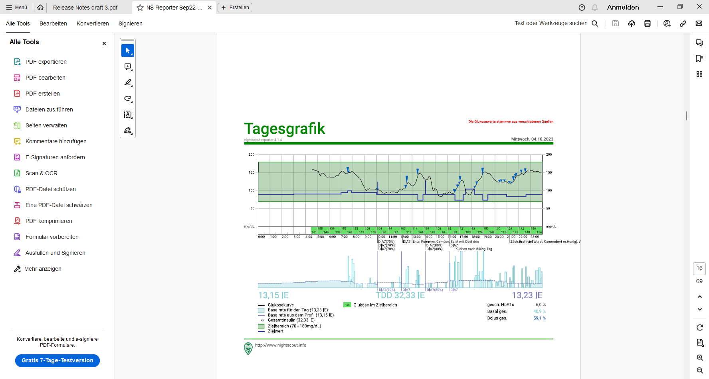

(No carbs entered, no bolus given). The lunch iob hump in middle of the bottom graph of the chart below shows that the 4.4 U iobTH was preventing higher iob as would be normal for a big lunch.

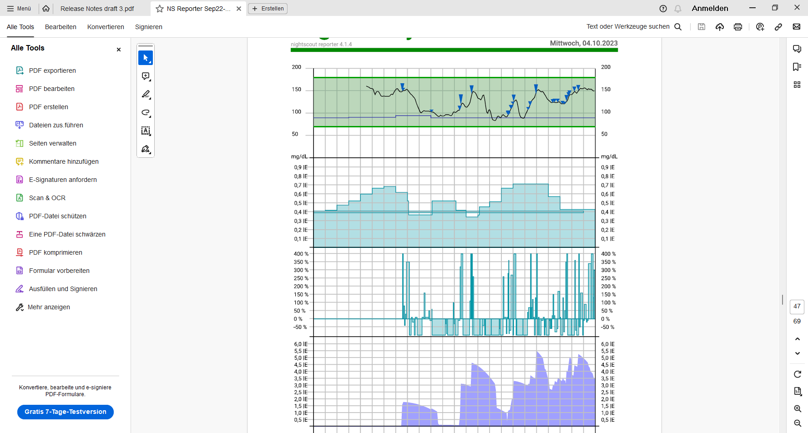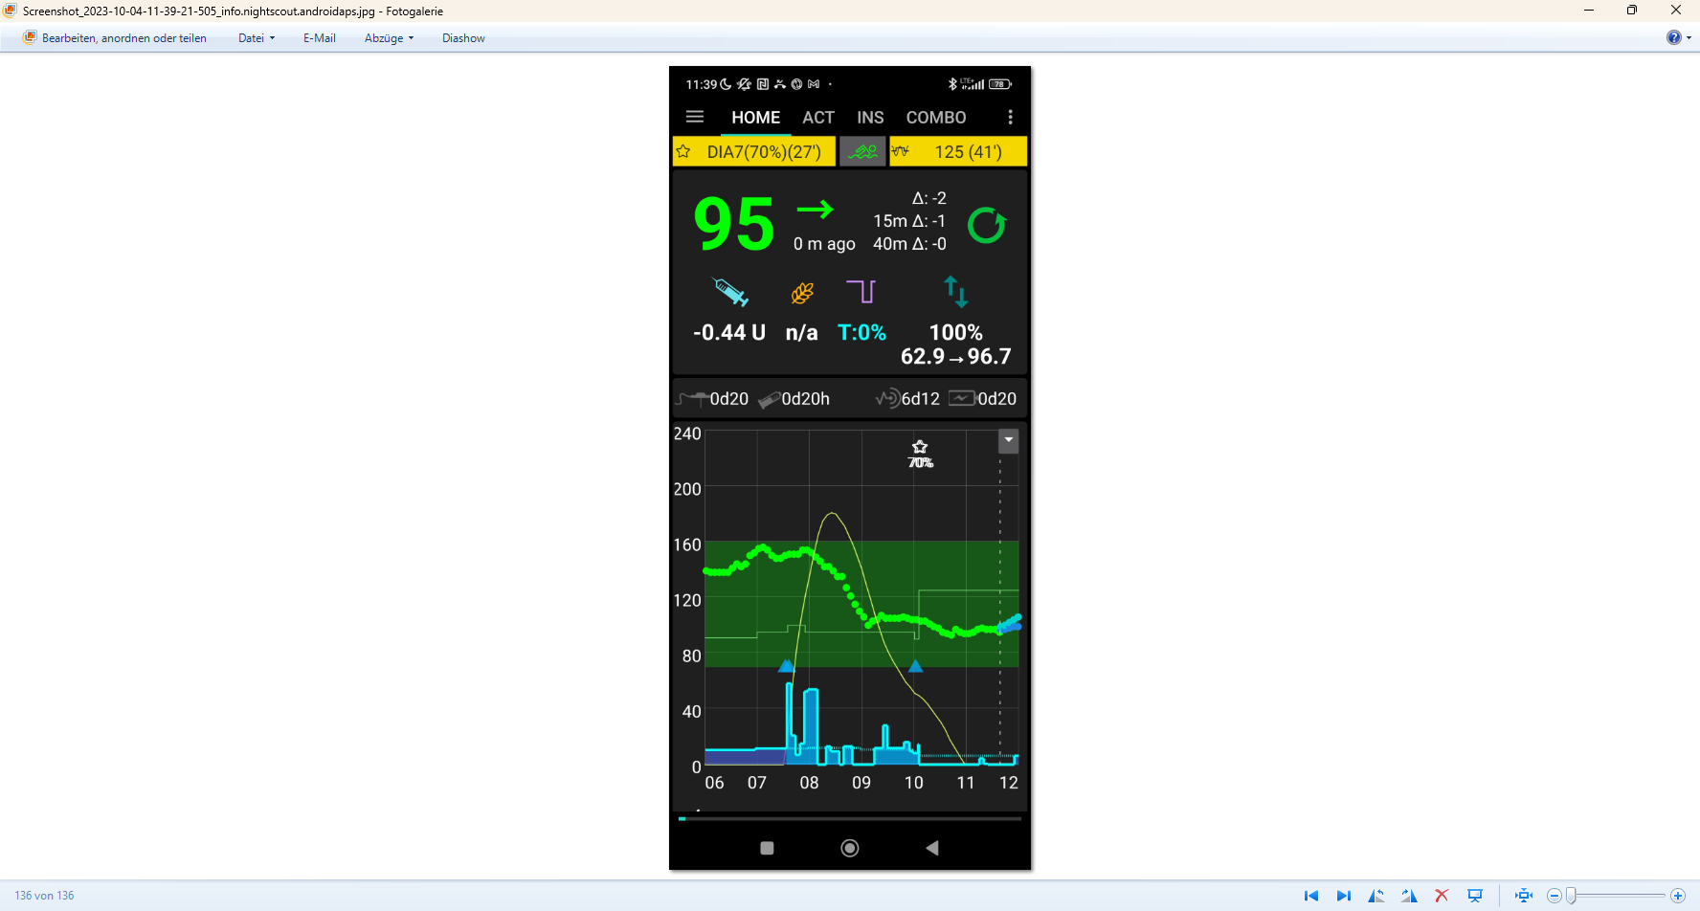

< **4.4 U**

**Conclusion from this example:**

The example demonstrated that using the exercise mode with a selected sports TT, and additionally setting a reduced temp. %profile, will soften the loop response.

The dynamic_iobTH that comes with the exercise mode allows, also at a day with exercise, that autoISF can be continued with the usual aggressive settings, and not cause a hypo.

1 time un-critical step operation with new UI. However, should the user during her/his exercise see a need to stop a selected mode or to change a setting, she/he can do this withinn 1-2 seconds right from the AAPS main screen („cockpit“).

For their kinds of favourite exercise, users must, over time, learn what combination of settings (half-basal_exercise_target,TT, %profile) leads to good-enough results.

As the loop re-calculates every 5 minutes, it is not important to get things exactly right. Adjustments (every 5 minutes) allow the loop to still keep things under good-enough control.

**Background: How sensitivity ratio is automatically reduced** (-> lower basal, higher ISF), **and how dynamic_iobTH works in the exercise mode** (-> lower iobTH, to reduce iob for meals on exercise days)

Key approach is to make use of the **exercise mode** (on AAPS main screen, top middle button, between profile and TT buttons), and set an elevated **temp. glucose target** for some hours, which overrides the normal (profile) target.

The delta (how much higher the set exercise target is above profile target) then defines what **reduced insulin sensitivity** the loop uses, in that time window.

* Besides selecting a suitable TT for the day, you can also generally tune this – to „calibrate“ to your sports intensity - - by playing with the new setting in AAPS preferences called **half basal exercise target**.
* Column C of the following table shows what results at my personal setting in preferences, 150 mg/dl half-basal target (line 17, colum C = 0.5, i.e. if I set TT=150 I reduce basal to half, hence the name).

So, you must decide **in the intial tuning stage** what basal reduction you want to have **for the kind of exercise you do**, and for the (range of) TTs that still can vary (between durations or varieties of exercise, garden work etc you are doing). –

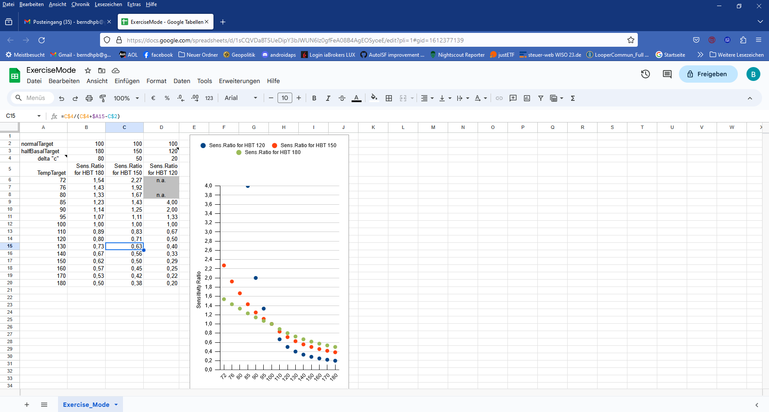

In the end, it is a combination of your general setting in Preferences, and what TT you set in your exercise mode, that lets you differentiate the desired loop aggressivenes.

The following table and chart shows in detail how autoISF translates your inputs into a milder loop action: Assuming sports TT > profile TT, all sensitivity ratios are below 1.0:

All effects are scaled to (half basal exercise target minus profile target).

The formula is given on top of the table. .

Example: 150 – 100 = 50. If I set 150 (line 17 in the picture), I am 50 over target and basal is cut by half.

If I go only 30 up to a TT=130 (line 15,blue box, and red dots in the curve), it is only uses 63% (which means cut 37% of insulin delivered without that sports setting).

Line 15 of the table above shows, how I would need to change my setting for halfBasaltarget, if I wanted stronger (set a 180 half-basal target, only 27% of profile basal would be the temp. sports basal.), or a lower basal ( 120 would set basal and iobTH to just 40% of default).

Note that via an Automation you could define under which conditions you would like to get one or two more powerful SMBs, and set a TT of e.g. 74 mg/dl for a couple of minutes, which „interrupts“ the exercise mode (and target) for a brief period ((example at line163-186 if it stays in))

**Dynamic_iobTH**: Like basal, also iobTH is modulated in autoISF when using the exercise mode.

Example for a default iobTH = 0.6 x maxIOB of 11 => 6 .6U: At TT 150, it would be 63% = 4.2 U; at TT=120 it would be 40% = 2.6 U; and at TT=180 it would 73%= 4.8 U.

A complementary measure you can take to set your system into a reduced insulin sensitivity is, to set a **reduced temp.% profile** on top of using the exercise Mode with an elevated TT.

This setting would multiply with the results in above table and further reduce basal BUT NOT iobTH. Dynamic_iobTH is strictly tied to the exercise mode and TT set.

Note that the time windows for doing the profile switch, and for setting a suitable TT can differ (and can also be automated so to not require multiple inputs over the course of your exercise day). Using all available tools allows a nearly surgical approach to what you want to achieve for your favourite type(s) of exercise..

**Logfile analysis with the emulator** *(clarify DEV questions, and shorten)*

Skip this last section, unless you like to learn more about using the emulator.

Analysis of my biking day with the emulator required to load the logfiles from my phone into the PC, and to have the files for the emulator downloaded from Github.

1. Load an empty vdf file, and access to logfiles (erasing the end with UTZ time, and putting an asterics after date_ => all of that date get loaded into the mask
2. Define the time window of interest, using UTZ (= MEZ summertime minus 2) in the last two lines (right hand side input fields) of the form:

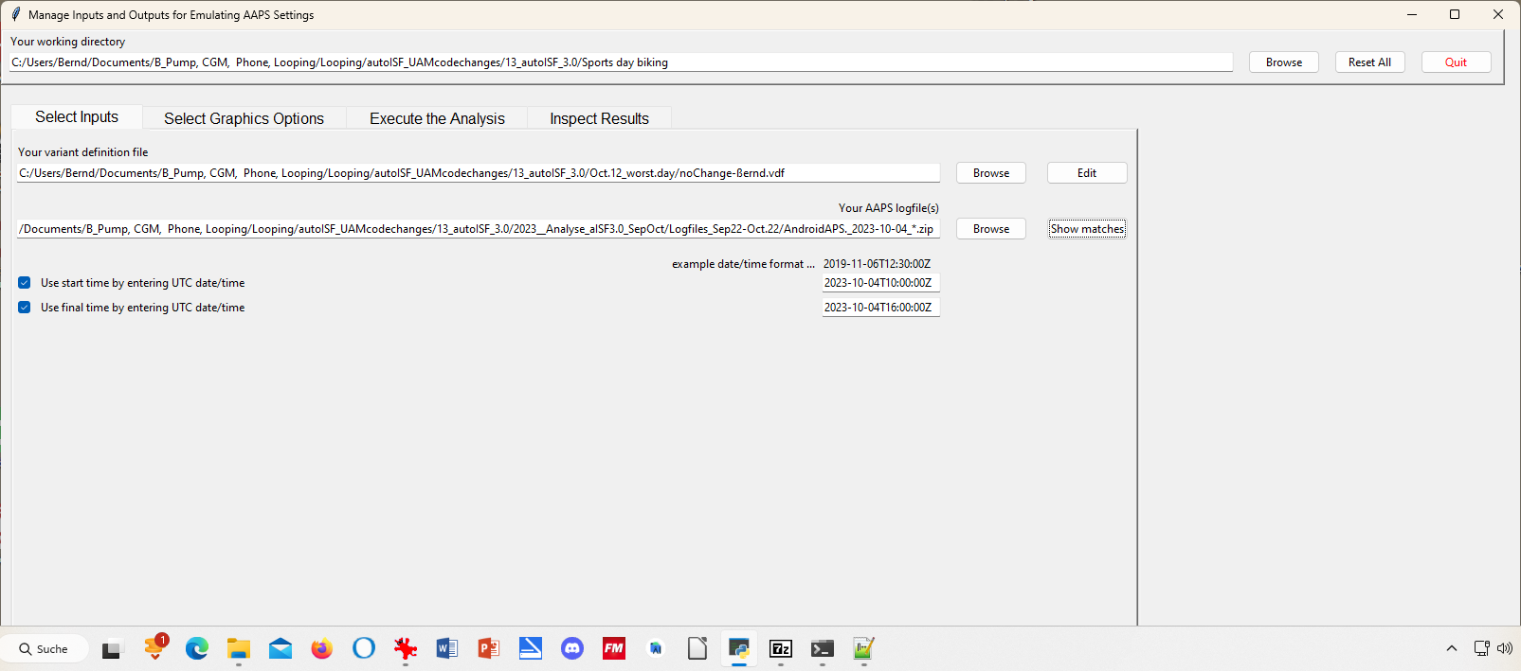

1. Execute Analysis / Run Emulation yields results as table:

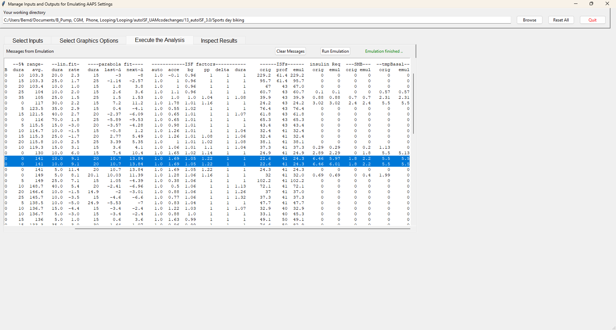

In line 6 (12:34 CET) a 2.4 U big SMB is given, driven by bgAcel_ISF factor of 1.78

Highlighted is 13:29 CET (for some reason there is duplicated line for it). Here, a big insulinReq of 6,5 U is cut down to a SMB of only 1.8 U..

1. … to see how our settings, TT and and sports button worked here, and what iobTH applied, we must look into the logs available from: ((alternatively, the SMB tab from exactly those 5 minutes would show, too))

Instead of Execute Analysis, press Inspect results…



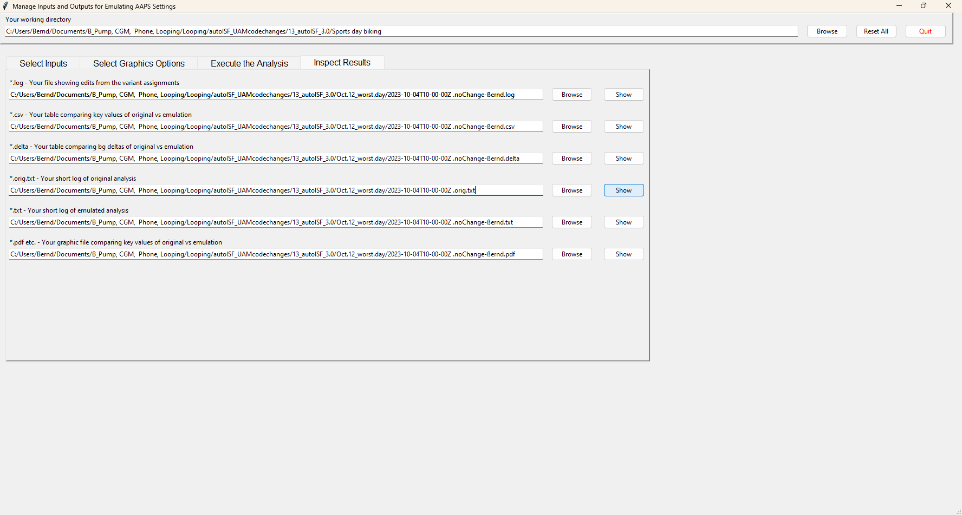

If you press the 4th option you get the logs which include basically all SMB tab info in an exhaustively long list.

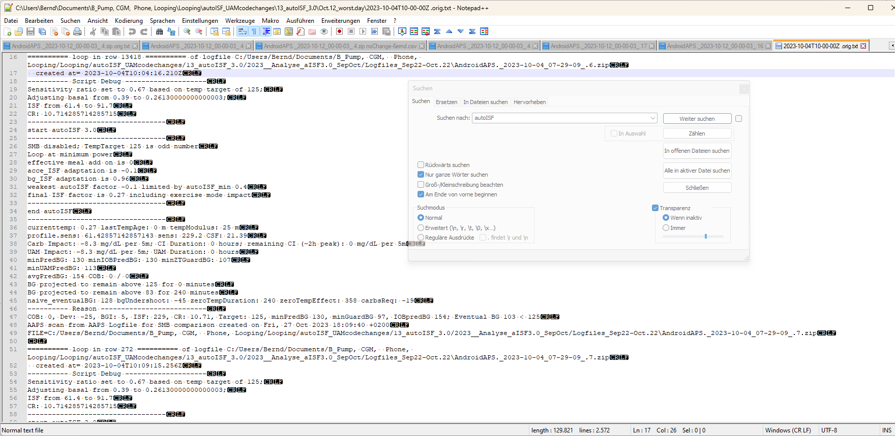

The blue highlighted line shows we are at 10:04 UTZ (12:04 CET) . We can see how sensitivity ratio and also basal were lowered due to sports setting with a 125 mg/dl TT, or 129 used a bit later, which also disabled SMBs.

By using the search function you can jump, in that long list, to all places that e.g. have „autoISF“ in it, or „script debug“, or „SMB disabled“ (if you want to analyze when that happened…)

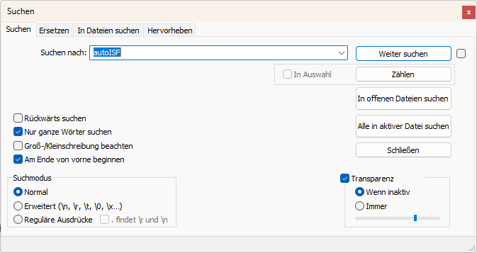

1. Now lets look at 11:29 UTZ (13:29 CET) which was when the first relevant size SMB was issued:

I copy out (and shorten texts) from the log table as above; first for the 11:24 UTZ which is when SMBs were not yet allowed.

at= 2023-10-04T11:24:14.355Z

---------- Script Debug --------------------

Autosens ratio: 1;

Basal unchanged: 0.55;

ISF unchanged: 41

CR: 7.5

----------------------------------

start autoISF 3.0

----DEV..what does next line mean, is it coming from (next version cancelled) „halving“?

SMB disabled by Full Loop logic: iob 1.998 is more than 15% of maxIOB 10

Full Loop pausing effective meal add on is 0

acce_ISF adaptation is 1.65

bg_ISF adaptation is 1.02

pp_ISF adaptation is 1.14

dura_ISF by-passed; bg is only 0m at level 130

final ISF factor is 1.65

----------------------------------

end autoISF

----------------------------------

BG projected to remain above 90 for 240 minutes

Target: 90, minPredBG 162, minGuardBG 136, IOBpredBG 125, UAMpredBG 225; Eventual BG 225 >= 90, adj. req. rate: 6.33 to maxSafeBasal: 5.5, temp 1.16 < 5.5U/hr.

It was unfortunate, that it required me to set a meal related TT (which I did in the next step), so the high accel_ISF factor actually can translate not only into insulinRequ. and also into a SMB .. (….which shall be reduced in size from our sports setting, but not get killed.)

Now 11:29 UTZ (13:29 CET), when SMB was delivered:

loop in row 14007 …..created at= 2023-10-04T11:29:11.005Z

---------- Script Debug --------------------

Sensitivity ratio set to 1.1 based on temp target of 74;

Adjusting basal from 0.55 to 0.6050000000000001;

ISF from 41 to 37.3

CR: 7.5

So, we see the meal TT of 74 temp. overrides the exercise target and significantly sharpens the applicable ISF: ((It also elevates basal ; note that TBRs can run several 100 of basal))

----------------------------------

start autoISF 3.0

----------------------------------

SMB enabled; TempTarget 74 is even number

Loop at full power

effective meal add on is 0.04

acce_ISF adaptation is 1.81

bg_ISF adaptation is 1.05

pp_ISF adaptation is 1.22

dura_ISF by-passed; bg is only 0m at level 141

final ISF factor is 1.81

----------------------------------

end autoISF

----------------------------------

profile.sens: 41 sens: 22.6 CSF: 3.01

minPredBG: 220 minIOBPredBG: 135 minZTGuardBG: 94 minUAMPredBG: 231

avgPredBG: 220 COB: 0 / 0

BG projected to remain above 74 for 240 minutes

IOB 2.033

Full loop capped SMB at 1.87 to not exceed 130 % of effective iobTH 30%

… maxBolus: 3.2

---------- Reason --------------------------

Eventual BG 304 >= 74, insulinReq 6.46. Microbolusing 1.8U. adj. req. rate: 13.53 to maxSafeBasal: 5.5, temp 2.75 < 5.5U/hr.

Developers. I understand the 130%, but why has my iobTH been cut in half …is it because somehow (although at TT 74 for the moment still) , the exercise button may be lighted „on“, still ?? has THIS halving of loop power been eliminated in newest version?? Then I erase this section 5)

1. At 11:34 UTC (13:34 CET) another SMB was delivered, and no more 5 minutes later, (….when the iobTH due to sports was already exceeded ? Check!):

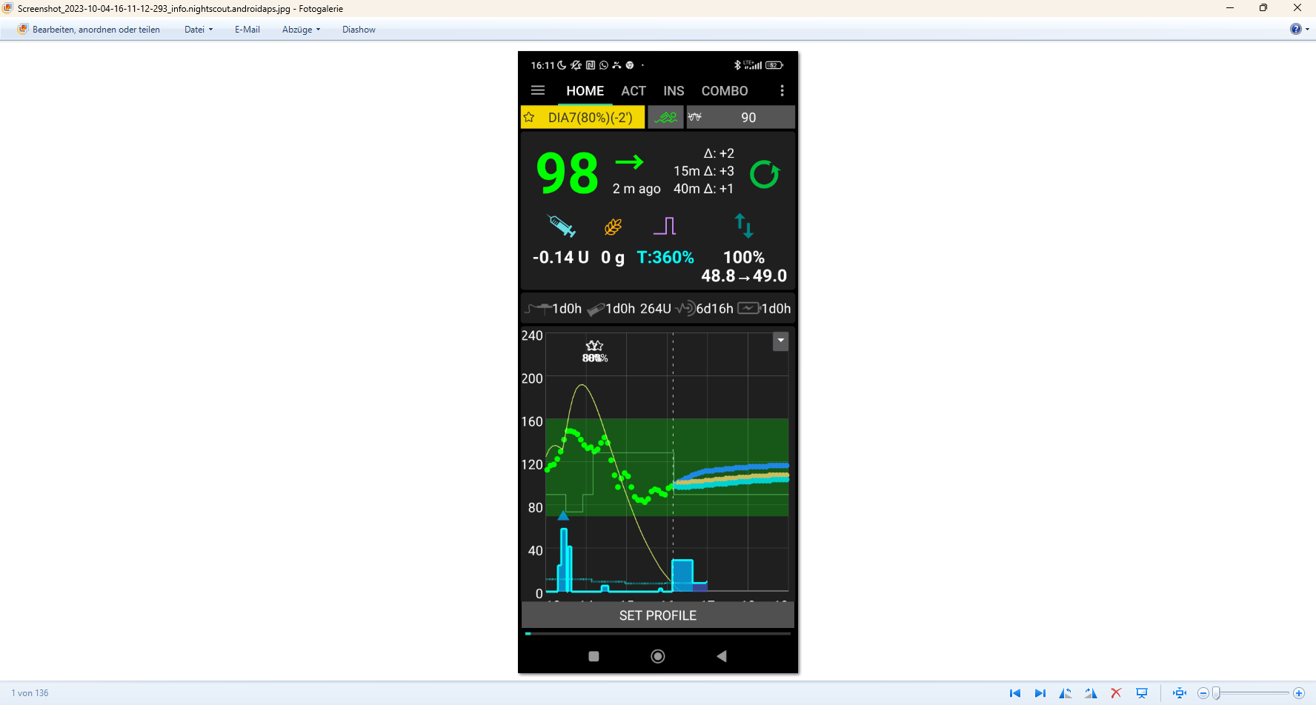

~13:30 …..16:11 h CET

13:34 CET …created at= 2023-10-04T11:34:21.067Z

---------- Script Debug --------------------

Sensitivity ratio set to 1.1 based on temp target of 74;

Adjusting basal from 0.55 to 0.6050000000000001;

ISF from 41 to 37.3

CR: 7.5

----------------------------------

start autoISF 3.0

----------------------------------

Full Loop modified max_iob 10 to effectively 11 due to profile % and/or exercise mode

SMB disabled by Full Loop logic: iob 3.863 is more than 30% of effective maxIOB 11

(again, has THIS halving of loop power been eliminated in newest version?? Then I erase this section 6) - Full Loop pausing

effective meal add on is 0

acce_ISF adaptation is 1.28

bg_ISF adaptation is 1.06

pp_ISF adaptation is 1.16

dura_ISF by-passed; bg is only 0m at level 149

final ISF factor is 1.28

----------------------------------

end autoISF

----------------------------------

profile.sens: 41 sens: 32

avgPredBG: 125 COB: 0 / 0

BG projected to remain above 74 for 240 minutes

, temp 0.00 < 1.99U/hr.

1. Lastly, let us look at the cake after 14:20 (16:20 CET):™

From 14:09 UTZ (16:09 CET) on, I discontinued the 129 sports TT and the loop reverted to 90 mg/dl profile target.

This made SMBs possible after starting to eat cake (then).

However, 14:14 - .19 - .24 and :29 there was no insulinRequired yet (while ISF factor gradually ramped up from 0.52 to 1,09 (line 1735, 1772, 1807) .

At 14:34 UTZ (16:34 CET) a first cake related SMB of 0.5 U was issued based on 0,66 U ins.Requ (line 1897), and based on a bgAccel_ISF factor of 1,54 (and final ISF factor of 1,52).

As there is a **>10 mg/d delta** (glucose rise), **my Automation** kicks in and sets for the next loop decisions (for 26 minutes is as my Automation defines it) a **TT=74** mg/dl which makes the loop more aggressive from 14:37 on:

created at= 2023-10-04T14:37:15.371Z

---------- Script Debug --------------------

Sensitivity ratio set to 1.1 based on temp target of 74;

Adjusting basal from 0.48 to 0.528;

ISF from 39 to 35.5

CR: 6.6

----------------------------------

start autoISF 3.0

----------------------------------

SMB enabled; TempTarget 74 is even number

Loop at full power

acce_ISF adaptation is 1.64

bg_ISF adaptation is 1

pp_ISF adaptation is 1.08

dura_ISF adaptation is 1.11 because ISF 35.5 did not do it for 30 m

final ISF factor is 1.64

----------------------------------

end autoISF

----------------------------------

profile.sens: 39 sens: 23.8

avgPredBG: 94 , BG projected to remain above 74 for 240 minutes

IOB 0.438 Eventual BG 100 >= 74, insulinReq 0.84. Microbolusing 0.6U.

created at= 2023-10-04T14:39:16.537Z

---------- Script Debug --------------------

Sensitivity ratio set to 1.1 based on temp target of 74;

Adjusting basal from 0.48 to 0.528;

ISF from 39 to 35.5

CR: 6.6

----------------------------------

start autoISF 3.0

----------------------------------

SMB enabled; TempTarget 74 is even number

Loop at full power

effective meal add on is 0.04

acce_ISF adaptation is 1.25

bg_ISF adaptation is 1

pp_ISF adaptation is 1.06

dura_ISF by-passed; bg is only 5m at level 97.5

final ISF factor is 1.25

----------------------------------

end autoISF

----------------------------------

profile.sens: 39 sens: 31.2

avgPredBG: 78 BG projected to remain above 74 for 240 minutes

IOB 1.114

Eventual BG 84 >= 74, insulinReq 0.13; setting 30m low temp of 0.04U/h. Microbolusing 0.1U.